Workforce Investment Areas  In New York State  http://www.workforcenewyork.org/wibtemplate/ | 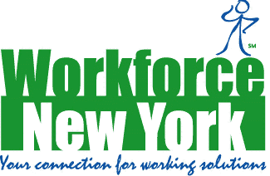
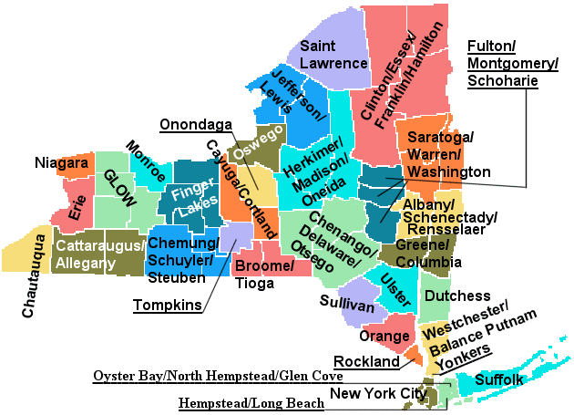
Albany/Rensselaer/Schenectady
Broome/Tioga
Buffalo/Erie
Cattaraugus/Allegany
Cayuga/Cortland
Chautauqua County
Chemung/Schuyler/Steuben
Chenango/Delaware/Otsego
Clinton/Essex/Franklin/Hamilton
Columbia/Greene
Dutchess County
Fulton/Montgomery/Schoharie
Genesee/Livingston/Orleans/Wyoming
Hempstead/Long Beach
Jefferson/Lewis
Monroe County
New York City
Niagara County
Oneida/Herkimer/Madison
Ontario/Wayne/Seneca/Yates
Orange County
Oswego County
Oyster Bay/North Hempstead/Glen Cove
Rockland County
Saratoga/Warren/Washington
St. Lawrence County
Suffolk County
Sullivan County
Syracuse/Onondaga
Tompkins County
Ulster County
Westchester Balance/Putnam
Yonkers City

